BOARD OF ZONING ADJUSTMENT

AGENDA

July 29, 2014

TABLE OF CONTENTS

Minutes June 24, 2014 3
Agenda July 29, 2014 14
Letter to Chris Armor 17
LOCATION MAP 812 BRADLEY ST SW 18
TABLED CASE 607 14TH ST SE 19
LOCATION MAP 607 14TH ST SE 20
CASE NO 1 224 ROBINSON ST SW 21
QUESTIONNAIRE 22
LOCATION MAP 224 ROBINSON ST SW 23
case no 2 532 10th ave nw 24
QUESTIONNAIRE 25
LOCATION MAP 532 10TH AVE NW 26
CASE NO 3 2404 DUNCANSBY DR SW 27
QUESTIONNAIRE 28
LOCATION MAP 2404 DUNCANSBY DR SW 29
CASE NO 4 1713 CAGLE AVE SW 30
QUESTIONNAIRE 31
LOCATION MAP 1713 CAGLE AVE SW 32
case no 5 1809 cumberland ave sw 33
QUESTIONNAIRE 34
LOCATION MAP 1809 CUMBERLAND AVE SW 35
CASE NO 6 3311 WHEAT AVE SW 36
QUESTIONNAIRE 37
LOCATION MAP 3311 WHEAT AVE SW 38
case no 7 2906, 2912 & 2918 Modaus rd sw 39
REQUEST FOR EVENT VENUE ONLY 40
DEFINITION OF EVENT VENUE 42
LOCATION MAP 2918 MODAUS RD SW 43

Minutes June 24, 2014

MEMBERS PRESENT: Chairman George Barran, Messrs., Mr. Larry Waye, Mr. Greg Dobbs, and Ms. Frances Tate

SUPERNUMERARIES: Ms. Sally Jo Green

OTHERS PRESENT: Mr. Wally Terry, Director
…..and Custodian of Records
Mr. Herman Marks, City Attorney
Mrs. Karen Smith, Planner
Mr. Chuck Ard, Councilman
Mr. Bob Sims, Building Inspector
Ms. Judy Bosworth, Recorder

Chairman George Barran called the meeting to order at 4:00 p.m. in the Council Chambers at City Hall. Mr. Bob Sims called the roll.

Mr. Greg Dobbs moved to approve the minutes of the May meeting as printed. Ms. Frances Tate seconded the motion. On a voice vote, the motion carried.

The Board considered the following applications and appeals.

CASE NO 1 – Tabled from last month.

Application and appeal of Amanda Whitley for a determination as a use permitted on appeal as allowed in Section 25-10 and as defined in Article VI, as amended and adopted, of the Zoning Ordinance to have an administrative office for a photography business at 2827 Winthrop DR SW, property located in a R-2 Single-Family Zoning District.

The Board voted to dismiss this case per the applicant’s request.

CASE NO 2 – Tabled from last month

Application and appeal of Reeves General Contractors, Inc for a 25 foot front-yard setback variance from Section 25-10.11(2)(c) and 25-2(1) of the Zoning Ordinance in order to construct an accessory structure in the front yard at 715 Cedar Lake Rd SW, property located in an R-4 Multi-Family Zoning District.

The Board voted to dismiss this case due to failure of the applicant to appear before the Board and present the case.

CASE NO 3

Application and appeal of Jorge Ramirez for a determination as a use permitted on appeal as allowed in Section 25-10 and as defined in Article VI, as amended and adopted, of the Zoning Ordinance to have an administrative office for a business to rent inflatable’s at 2903 Whiteford Dr SW, property located in a R-2 Single-Family Zoning District.

Mr. Jorge Ramirez presented this case to the Board. Mr. Ramirez stated he would like an administrative office to have a business renting inflatables. Mr. Ramirez also stated he would store them on a trailer and in his garage. After the Board pointed out that storing the inflatables on-site could be problematic, Mr. Ramirez stated he could store them off-site. Mr. Ramirez further stated he would have no employees at this time.

Mr. Waye explained to Mr. Ramirez employees could not come to his house and further he would need to clean and make repairs to the inflatables off-site. Additionally, if he had a sign on his vehicle it could not contain his address.

Mr. Lenard Hall, stated he lived next door to Mr. Ramirez and he had concerns about additional traffic and the inflatables being on display. Mr. Ramirez stated when one was inflated on his lot, it was for his own children’s use.

Mr. Rex Terry of 2902 Whiteford Dr SW, stated he was not opposed to an administrative office but the inflatables were already in view and Mr. Ramirez has a very large backyard where several could be displayed. Mr. Terry also stated the parking was an issue to the neighborhood.

Mr. George Barran explained to Mr. Terry if the neighbors have a complaint that Mr. Ramirez is using his home for more than an administrative office, they can complain to the Building Department and their license could possibly be revoked.

Mr. Rex Terry suggested the Entrepreneurial Center would be a good place for this type business and it might be a good policy for the Board to consider.

Mr. Sims stated the Building Department would recommend approval with the condition the inflatables be stored and repaired off-site.

Mrs. Smith stated the Planning Department would concur with the Building Department.

Mr. Greg Dobbs moved to approve this home occupation request with the understanding it is for administrative office use only; all storing, cleaning and repairs of the inflatables are to be performed off-site. Ms. Sally Jo Green seconded the motion. On a roll-call vote, the motion carried.

CASE NO 4

Application and appeal of Patty J. Darnell for a determination as a use permitted on appeal as allowed in Section 25-10 and as defined in Article VI, as amended and adopted, of the Zoning Ordinance to have an administrative office to act as a travel agent at 1707 Westmeade St SW, property located in a R-2 Single-Family Zoning District.

Ms. Patty J. Darnell presented this case to the Board. Ms. Darnell stated she would like an administrative office for a travel agent business. She also stated she has no employees.

Mr. Larry Waye asked if anyone would come to her home for meetings. Mrs. Darnell stated she has access to a conference room so no one would be coming to her home.

Mr. Sims stated the Building Department would recommend approval.

Mrs. Smith stated the Planning Department had no comment.

Mr. Larry Waye moved to approve this home occupation request as submitted. Ms. Sally Jo Green seconded the motion. On a roll-call vote, the motion carried.

CASE NO 5

Application and appeal of James F. Goins for a determination as a use permitted on appeal as allowed in Section 25-10 and as defined in Article VI, as amended and adopted, of the Zoning Ordinance to have an administrative office for a general contracting/remodeling business at 2416 Jarvis St SW, property located in a R-2 Single-Family Zoning District.

Mr. James F. Goins presented this case to the Board. Mr. Goins stated he needed an administrative office for a remodeling business. Mr. Goins also stated he kept his tools in his garage and he had no employees.

Mr. Sims stated the Building Department would recommend approval with the understanding no heavy equipment or materials could be kept on-site.

Mrs. Smith stated the Planning Department would recommend approval.

Mr. Larry Waye moved to approve this home occupation request as submitted. Mr. Greg Dobbs seconded the motion. On a roll-call vote, the motion carried.

CASE NO 6

Application and appeal of Joshua B. Tidwell for a determination as a use permitted on appeal as allowed in Section 25-10 and as defined in Article VI, as amended and adopted, of the Zoning Ordinance to have an administrative office for a pressure washing business at 801 9th St SE, property located in a R-3 Single-Family Zoning District.

Mr. Joshua B. Tidwell presented this case to the Board. Mr. Tidwell stated he would like an administrative office for a pressure washing business. Mr. Tidwell also stated his pressure washer would be kept in storage and he would advertise on his vehicle. Mr. Tidwell stated he has no employees but his buddy would help him.

Mr. Larry Waye stated the sign on the vehicle could not contain his address and advertising on his premises would not be allowed.

Mr. George Barran stated Mr. Tidwell’s buddy could not report to his home for work.

Mr. Sims of the Building Department and Mrs. Smith of the Planning Department both stated they would recommend approval.

Mr. Greg Dobbs moved to approve this home occupation request as submitted. Ms. Frances Tate seconded the motion. On a roll-call vote, the motion carried.

CASE NO 7

Application and appeal of Meaghan Thrasher for a determination as a use permitted on appeal as allowed in Section 25-10 and as defined in Article VI, as amended and adopted, of the Zoning Ordinance to have an administrative office for a business to calibrate individual fishing and game scales at 1305 Noble Ave SW, property located in a R-2 Single-Family Zoning District.

Ms. Meaghan Thrasher presented this case to the Board. Ms. Thrasher stated she would like an administrative office to calibrate fishing and gaming scales. Ms. Thrasher further stated the scales would be shipped from the client to her home via Fed-X, UPS, or United Postal Service.

Mr. Larry Waye asked Ms. Thrasher if she was going to use more than one room for this business as marked on her questionnaire. Ms. Thrasher stated the scales would be calibrated in the garage.

Mr. Sims stated the Building Department would recommend approval.

Mrs. Smith inquired as to the size of the scales that would be used to weigh the heavier game.

Ms. Thrasher stated some of the scales could be large enough to weigh big game.

Mrs. Smith stated the Planning Department would recommend approval with the understanding the applicant would go off-site to calibrate the larger scales.

Mr. Greg Dobbs moved to approve this home occupation request as submitted. Ms. Sally Jo Green seconded the motion. On a roll-call vote, the motion carried.

CASE NO 8

Application and appeal of Meaghan Thrasher for a determination as a use permitted on appeal as allowed in Section 25-10 and as defined in Article VI, as amended and adopted, of the Zoning Ordinance to have an administrative office for a residential and commercial cleaning service at 1305 Noble Ave SW, property located in a R-2 Single-Family Zoning District.

Ms. Thrasher presented this case to the Board. Ms. Thrasher stated she would like an administrative office for a cleaning business. Ms Thrasher also stated the employees would meet at the work site. Additionally, Ms. Thrasher stated she may store small amounts of supplies at her house but typically the client would supply those items.

Mr. Sims of the Building Department and Mrs. Smith of the Planning Department both stated they would recommend approval.

Mr. Larry Waye moved to approve this home occupation request as submitted. Mr. Greg Dobbs seconded the motion. On a roll-call vote, the motion carried.

CASE NO 9

Application and appeal of April D. Pruitt for a determination as a use permitted on appeal as allowed in Section 25-10 and as defined in Article VI, as amended and adopted, of the Zoning Ordinance to have an administrative office to provide customer service on-line and via telephone for AT & T customers at 217 Cedar Lake Rd SW, Apt 7, property located in a R-4 Single-Family Zoning District.

Ms. April D. Pruitt presented this case to the Board. Ms. Pruitt stated she would like an administrative office to work for various vendors such as AT & T, T-Mobile, Disney and others where she would field in-bound calls for customer service. Ms. Pruitt also stated she had no employees at this time but as her business grows and she has the need to hire employees she would get a commercial office. Ms. Pruitt also stated there would be no traffic coming to her home.

Mr. Sims stated the Building Department would recommend approval.

Mrs. Smith stated the Planning Department would concur with the Building Department.

Ms. Sally Jo Green moved to approve this home occupation request as submitted. Mr. Greg Dobbs seconded the motion. On a roll-call vote, the motion carried.

CASE NO 10

Application and appeal of Alyson Moody for a determination as a use permitted on appeal as allowed in Section 25-10 and as defined in Article VI, as amended and adopted, of the Zoning Ordinance to have an administrative office for an on-line embroidery business at 3201 Battlement Rd SW, property located in a R-2 Single-Family Zoning District.

This case was moved to the end of the meeting since no one came forward to present the case when called.

CASE NO 11

Application and appeal of David L. Horsley for a determination as a use permitted on appeal as allowed in Section 25-10 and as defined in Article VI, as amended and adopted, of the Zoning Ordinance to have an administrative office to generate financial reports for businesses at 2215 12th St SE, property located in a R-2 Single-Family Zoning District.

Mr. David L. Horsley presented this case to the Board. Mr. Horsley stated he would like an administrative office for a financial reporting business where he would be using his computer and phone to conduct business.

Mr. Sims stated the Building Department would recommend approval.

Mrs. Smith stated the Planning Department would concur with the Building Department.

Mr. Greg Dobbs moved to approve this home occupation request as submitted. Mr. Larry Waye seconded the motion. On a roll-call vote, the motion carried.

CASE NO 12

Application and appeal of Danny W. Hill for a 6 foot rear-yard setback variance to Section 25-10.9(2)(d) of the Zoning Ordinance in order to construct a covered patio at 1200 Darrowby LN SW, property located in a R-2 Single-Family Zoning District.

Mr. Danny W. Hill presented this case to the Board. Mr. Hill stated he was representing his client who wanted to construct a covered patio and needed a 6 foot rear-yard variance to do so.

Mr. Sims stated the Building Department would recommend approval.

Mrs. Smith stated the Planning Department had no comment.

Ms. Sally Jo Green moved to approve this request as submitted. Mr. Larry Waye seconded the motion. On a roll-call vote, the motion carried.

CASE NO 13

Application and appeal of Pugh Wright McAnally for a use variance to Section 25-12.1 of the Zoning Ordinance to be able to construct a car wash at 511 Beltline Rd SW, property located in an AG-1 Agricultural Zoning District.

Mr. Larry Waye recused himself from the voting on this case.

Chairman, George Barran gave the option to table this case if the applicant desired since there were only four voting members left.

The applicants chose to proceed with the case.

Mr. Richard Humphries of Pugh Wright McAnally presented this case to the Board. Mr. McAnally stated a certificate to rezone the properties at this address had been submitted to the Planning Department because the property contained two different zoning classifications which are AG-1 and M1-A. Mr. Humphries also stated his client would like to start construction of an accessory structure on the portion zoned M1-A while their request for rezoning was being processed.

Mr. Greg Dobbs questioned if they could construct the entire facility on the M1-A portion and if they could get a permit at this time.

Mr. Bob Sims stated they would not be able to get a permit at this time.

Mrs. Smith stated the client had been before the Planning Commission and their approval was pending the council action and required public hearings on the rezoning of the property. Mrs. Smith also stated the issues with the Alabama Department of Transportation should not be a concern at this time because they would be resolved before the site plan could be approved or the building permit sold.

Ms. Frances Tate stated the rezoning needed to be completed before starting construction.

Mr. Richard Humphries stated they were scheduled to go before the City Council the first week in August.

Mr. Sims stated the Building Department would recommend disapproval.

Mrs. Smith stated the Planning Department would recommend waiting for the rezoning to run the course.

Ms. Frances Tate moved to approve this request as submitted. Mrs. Sally Jo Green seconded the motion. On a roll-call vote, the motion failed with three members voting against and one in favor.

CASE NO 14

Application and appeal of Epic Church for a variance from Section 25-80(a) of the Zoning Ordinance to reestablish the grandfather status of the abandoned sign at 607 14th St SE, property located in a M-1 Industrial Zoning District.

Mr. Greg Dobbs recused himself from the voting on this case.

Chairman, George Barran gave the option to table this case if the applicant desired since there were only four voting members left.

Mr. Justin Potter spokesman for Epic Church choose to Table their request until next month.

CASE NO 15

Application and appeal of Neal Holland for a use permitted on appeal from Section 25-11(a) of the Zoning Ordinance in order to provide training lessons and show dogs and horses and have retail sales of related items at 2906, 2912, and 2918 Modaus Rd SW, property located in an AG-1 Agricultural Zoning District.

Attorney Barney Lovelace presented this case to the Board. Attorney Lovelace stated his client Neal Holland wanted to construct a facility to show and board horses and dogs on the three lots listed on his application.

Mr. Larry Waye questioned the extent of the retail aspect stated on the application.

Attorney Barney Lovelace stated this was not going to be a full blown retail store, his client just wanted to sell items related to the showing and boarding of dogs and horses. Mr. Lovelace also stated his client may want to have an event center but he is not sure at this time if he wants to proceed.

Mr. Herman Marks asked if the event center was included in the advertisement with the Decatur Daily. The Building Department replied that it was not included. Therefore, Mr. Marks stated an event center could not be addressed at this time since it was not advertised but Items one and two on the application could be discussed.

Mrs. Karen Smith brought up concerns about the size of the retail space that Mr. Holland is seeking to have in an AG-1 Zoning District.

There were discussions of a possible size limitation for the retail space. Attorney Barney Lovelace suggested 1,000 square feet while Mrs. Karen Smith suggested 500 square feet.

Mr. Wally Terry mentioned concerns about defining incidental as specific to this scenario and provide some guidance to control the size of retail in an Ag-1 Zoning District. Mr. Terry stated whatever amount of retail space was decided on would need to be managed in some way.

Attorney Barney Lovelace stated he was asking for 1,000 square feet of the future building devoted to retail space.

Mrs. Karen Smith suggested 500 square feet devoted to retail, limit signage and require all parking to be located behind the building.

Attorney Barney Lovelace disagreed with the limitations suggested by Mrs. Karen Smith. Additionally questioning why was it necessary for all parking to be behind the building.

Mrs. Smith stated there were parking concerns because of the residential houses surrounding the property. Mrs. Smith also suggested the perimeter of the property be buffered with landscaping.

Attorney Barney Lovelace wanted to know why Mr. Holland would have to buffer his own property.

Mr. Herman Marks suggested the sign restrictions suggested by Mrs. Smith be stricken.

Mr. Greg Dobbs stated to Attorney Barney Lovelace the Board was not presented with enough information concerning a layout or drawing; Therefore, making a decision more difficult for them.

Mr. Larry Waye questioned how the issue would be handled in the future if the Board approves this request and then this business grows to more than what was approved. It was stated the Building Department would go out and review if a complaint was received.

Mr. Larry Waye moved to approve this request as submitted and as advertised in the paper which is to allow what was on the application excluding the event venue. Mr. Greg Dobbs seconded the motion. On a roll-call vote, the motion carried.

CASE NO 10

Application and appeal of Alyson Moody for a determination as a use permitted on appeal as allowed in Section 25-10 and as defined in Article VI, as amended and adopted, of the Zoning Ordinance to have an administrative office for an on-line embroidery business at 3201 Battlement Rd SW, property located in a R-2 Single-Family Zoning District.

This case was called again. When no one came forward to present, the Board voted to dismiss the case.

The meeting adjourned at 5:25

____________________________
Chairman, George Barran

Agenda July 29, 2014

Old Business: Chris Armor - 812 Bradley ST SW

This case is being brought before the Board again to review the conditions set forth in the July 2013 meeting which were as follows:
- A rear yard buffer be put in place.
- Adherences to the Zoning Ordinance from Section 25-16(9)(c) (iii) and 25(9)(f)(i) concerning landscaping.
- Bring the building up to code per the City’s requirements.
- Have landscaping approved by Planning.

Tabled Case from last month’s meeting – Epic Church

Application and appeal of Epic Church for a variance from Section 25-80(a) of the Zoning Ordinance to reestablish the grandfather status of the abandoned sign at 607 14th St SE, property located in a M-1 Industrial Zoning District.

CASE NO 1

Application and appeal of Angelica V. Huerta for a determination as a use permitted on appeal as allowed in Section 25-10 and as defined in Article VI, as amended and adopted, of the Zoning Ordinance to have an administrative office for a lawn care and lawn scape company at 224 Robinson St SW, property located in a R-2 Single-Family Zoning District.

CASE NO 2

Application and appeal of Shelika Moore for a determination as a use permitted on appeal as allowed in Section 25-10 and as defined in Article VI, as amended and adopted, of the Zoning Ordinance to have a home office for hair care services at 532 10th Ave NW, property located in a R-4 Multi-Family Zoning District.

CASE NO 3

Application and appeal of James Patrick Martin for a determination as a use permitted on appeal as allowed in Section 25-10 and as defined in Article VI, as amended and adopted, of the Zoning Ordinance to have an administrative office to bake cakes at 2404 Duncansby Dr SW, property located in a R-2 Single-Family Zoning District. This business would be conducted under the guidelines of the Alabama Cottage Food Law SB159.

CASE NO 4

Application and appeal of Brandi C. Sparks for a determination as a use permitted on appeal as allowed in Section 25-10 and as defined in Article VI, as amended and adopted, of the Zoning Ordinance to have an administrative office to receive inbound calls for Arise Virtual Solutions at 1713 Cagle Ave SW, property located in a R-1 Single-Family Zoning District.

CASE NO 5

Application and appeal of Jerica White for a determination as a use permitted on appeal as allowed in Section 25-10 and as defined in Article VI, as amended and adopted, of the Zoning Ordinance to have a home day care for six children or less from 6:00 a.m. to 6:00 p. m. at 1809 Cumberland Ave SW, property located in a R-2 Single-Family Zoning District.

CASE NO 6

Application and appeal of Emily Carlson for a determination as a use permitted on appeal as allowed in Section 25-10 and as defined in Article VI, as amended and adopted, of the Zoning Ordinance to have a home day care for six children or less from 7:00 a.m. to 5:30 p.m. at 3311 Wheat Ave SW, property located in a R-2 Single-Family Zoning District.

CASE NO 7

Application and appeal of Neal Holland for a use permitted on appeal from Section 25-11(a) of the Zoning Ordinance to have an event venue at 2906, 2912 and 2918 Modaus Rd SW, property located in a AG-1 Agricultural Zoning District.

OLD BUSINESS:

THE FOLLOWING IS A COPY OF THE MOTION FROM THE JULY 2013 MEETING ON THE REQUIREMENTS FOR CHRIS ARMOR’S PROPERTY. THE BUILDING DEPARTMENT FELT THERE WAS A NEED TO REVIST THIS CASE.

- A rear yard buffer be put in place.
- Adherences to the Zoning Ordinance from Section 25-16(9)(c) (iii) and 25(9)(f)(i) concerning landscaping.
- Bring the building up to code per the City’s requirements.
- Have landscaping approved by Planning.

Letter to Chris Armor
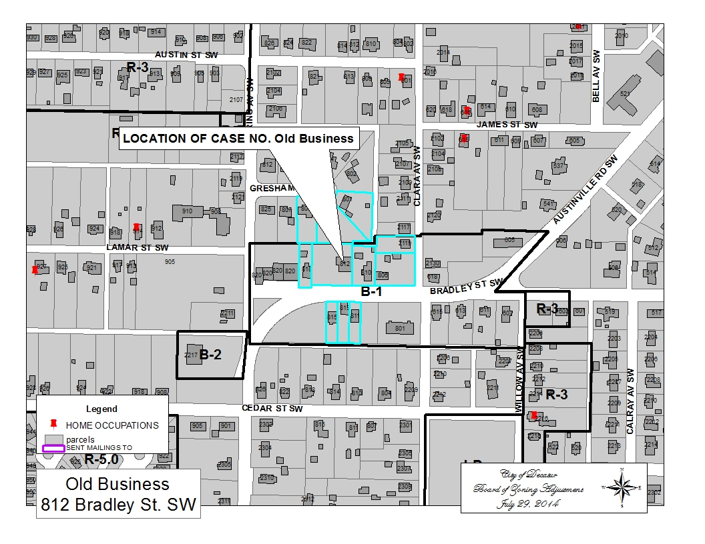

LOCATION MAP 812 BRADLEY ST SW

TABLED CASE 607 14TH ST SE

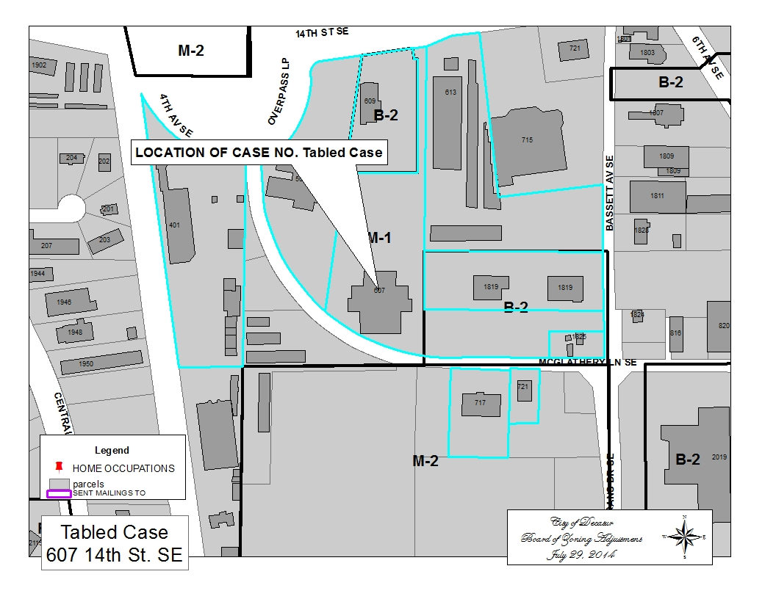

LOCATION MAP 607 14TH ST SE

CASE NO 1 224 ROBINSON ST SW

QUESTIONNAIRE

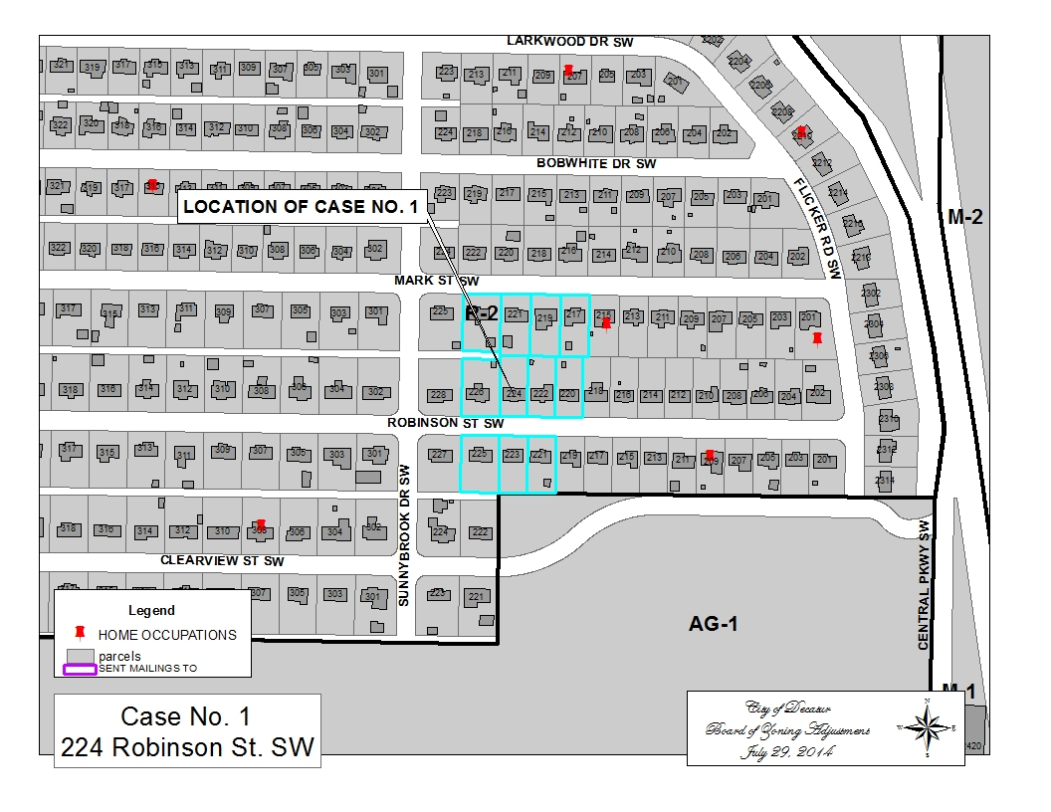

LOCATION MAP 224 ROBINSON ST SW

case no 2 532 10th ave nw

QUESTIONNAIRE
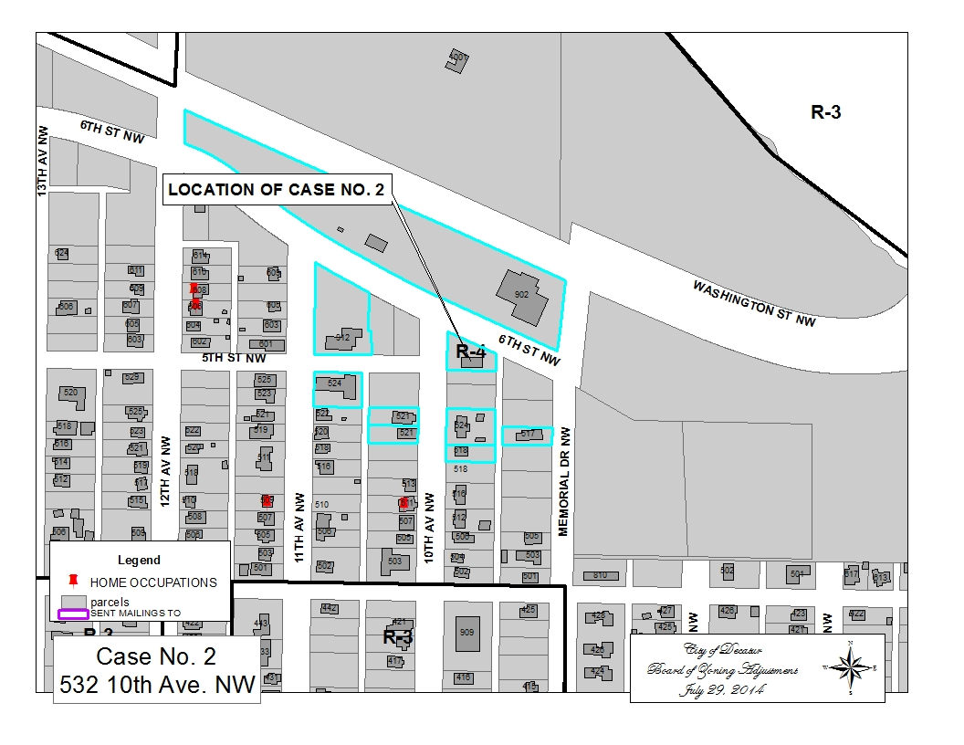

LOCATION MAP 532 10TH AVE NW

CASE NO 3 2404 DUNCANSBY DR SW

QUESTIONNAIRE
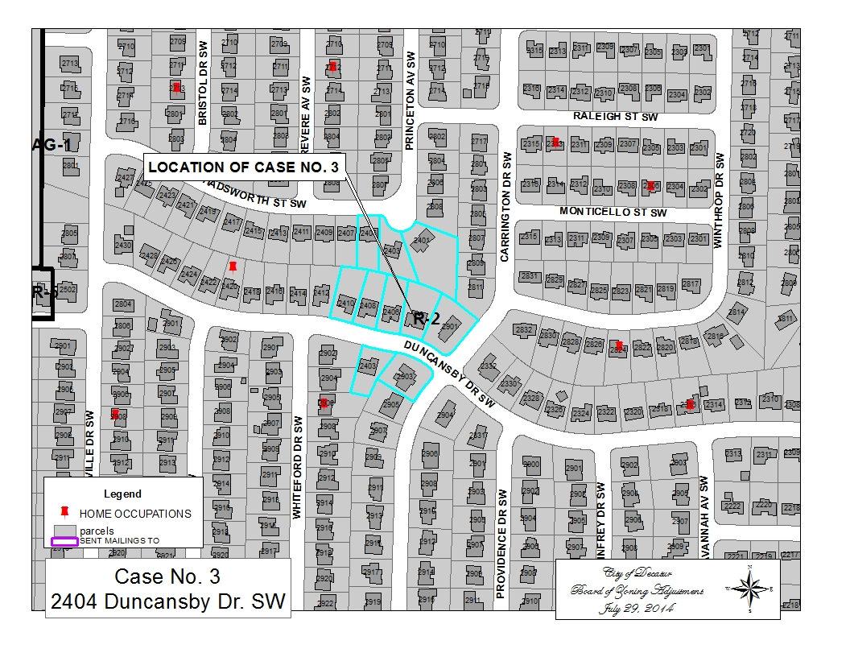

LOCATION MAP 2404 DUNCANSBY DR SW

CASE NO 4 1713 CAGLE AVE SW

QUESTIONNAIRE
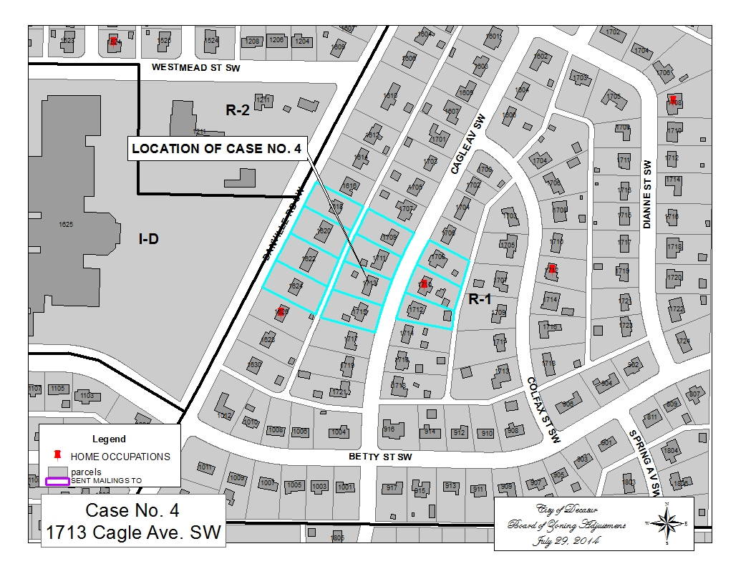

LOCATION MAP 1713 CAGLE AVE SW

case no 5 1809 cumberland ave sw

QUESTIONNAIRE

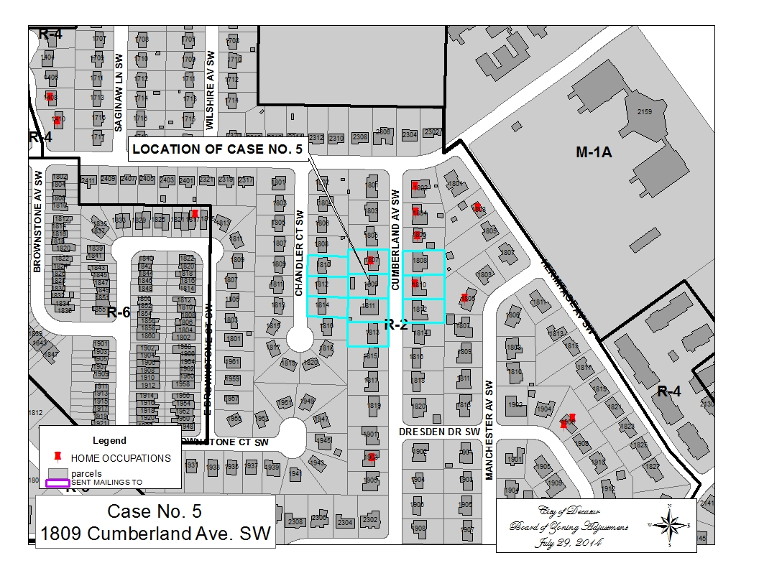

LOCATION MAP 1809 CUMBERLAND AVE SW

CASE NO 6 3311 WHEAT AVE SW

QUESTIONNAIRE
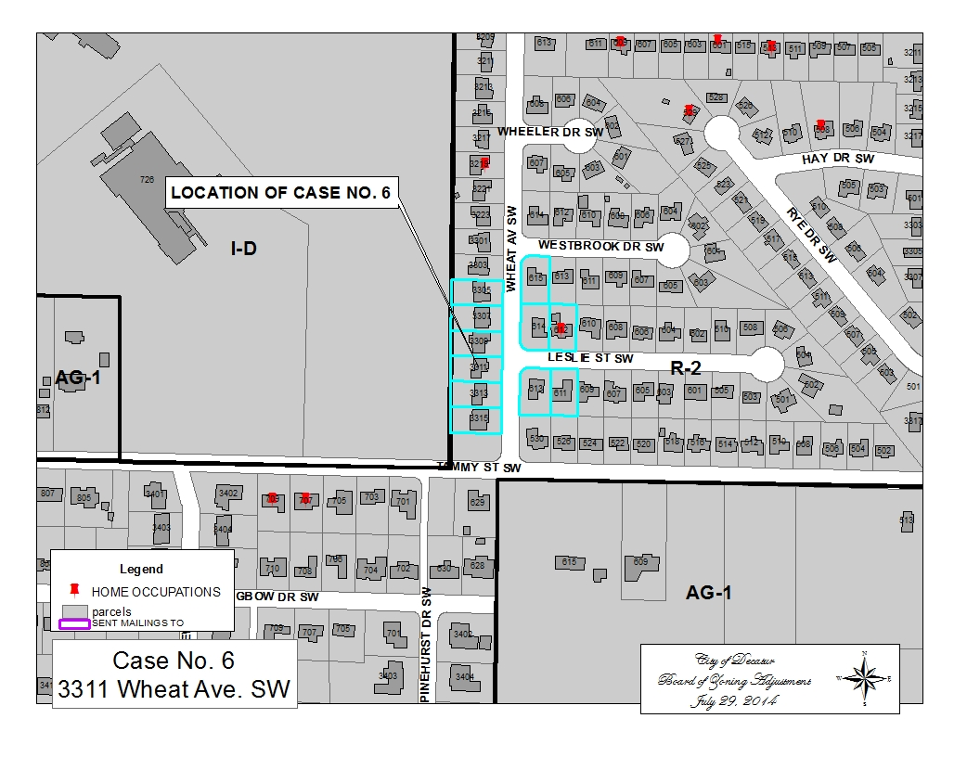

LOCATION MAP 3311 WHEAT AVE SW

case no 7 2906, 2912 & 2918 Modaus rd sw

REQUEST FOR EVENT VENUE ONLY

BE IT ORDAINED BY THE CITY COUNCIL OF THE CITY OF DECATUR, ALABAMA

Amendment to the Zoning Ordinance

The effect of the proposed amendment will be to amend Section 25-2 Definitions, 25-11 Business District Requirements and Section 25-12.1 Agricultural District Requirements as outlined below:

Section 1 That Section 25-2 Definitions is hereby amended to add a definition number (11a) to read as follows:

(11a) Event Venue: a public place where meals, food or refreshments are prepared and/or furnished upon premises. An Event Venue is only available for events on an occasional basis by contract, (e.g., showers, receptions, birthday parties, corporate meetings, and fund raisers or other similar events) with a designated onsite manager or the owner present during the event. Event Venues shall not be used for any other purpose or use. If alcohol is desired Event Venues shall be duly licensed as a special retail licensee. Event Venues are a permitted use in B1, B2, B3, B4, B5, and M1A zoning districts. Event Venues will be a Use Permitted on Appeal in AG1 and AG2 zoning districts. An Event Venue must meet all Building Code and Fire Code requirements along with all ABC (Alcoholic Beverage Control Board) requirements.

Section 2 The Paragraph entitled “Uses permitted” of the sub-section entitled B-1 (Local Shopping Business District) of Section 25-11 of the Code of Decatur, Alabama is hereby amended to read as follows:
Uses permitted: Off-premises sale of beer and table wine; neighborhood retail stores and markets, including the following types: food, general merchandise, apparel; furniture; household and hardware; radio and television; drugs and sundries; jewelry and gifts; florists; sporting goods; pet shops, photograph studios and photo retail sales. Neighborhood services including the following types: Dry cleaning and laundry pickup stations; customer operated launderettes and customer operated dry cleaning establishments; filling stations, provided, however, that gasoline storage above ground in excess of five hundred (500) gallons is prohibited; barber and beauty shops; shoe repair; offices, banks; post offices; event venues; playgrounds; parks; public building (i.e., municipal, county, state or federal, including public schools and libraries); public utilities; churches and similar places of worship; dancing and music academies; nurseries, kindergartens, or day care for children; parking lots.

Section 3 The Paragraph entitled “Uses permitted” of the sub-section entitled B-3 (Tourist Commercial District) of Section 25-11 of the Code of Decatur, Alabama is hereby amended to read as follows
Uses permitted: Clubs; on premises and off premises sale of alcoholic beverages; hotels, motels, trailer restaurants, event venues, novelty shops.
Section 4 The Paragraph entitled “Uses permitted” of the sub-section entitled B-4 (Regional Shopping) of Section 25-11 of the Code of Decatur, Alabama is hereby amended to read as follows
Uses permitted: Clubs; on premises and off premises sale of alcoholic beverages; any regional type retail stores and markets including the following types of retail business: Super markets, general merchandise, apparel, furniture, household and hardware, radio and television, drug and sundries, jewelry and gifts, florists, sporting goods, pet shops, banks, theaters, dry cleaning and laundry pick-up stations, barber and beauty shops, shoe repair, Event Venues, delicatessen and variety (5-10).Must have access to major artery. The plat or plan of the proposed subdivision shall have the approval of the planning commission and be filed for record before any commercial structures are built in these proposed districts.
Section 5 The Paragraph entitled “Uses permitted” of the sub-section entitled B-5 (Central Business District) of Section 25-11 of the Code of Decatur, Alabama is hereby amended to read as follows
Uses permitted: Off premises sale of alcoholic beverages; On premises sale of table wine; On premises sale of alcoholic beverages by the Princess Theatre Center for the Performing Arts and any other valid responsible organization of good reputation, if duly licensed as a special retail licensee; on premises sale of alcoholic beverages by duly licensed restaurants; and on premises sale of alcoholic beverages by lounges located in and constituting an integral part of a restaurant licensed by the Alabama Alcoholic Beverage Control Board to sell alcoholic beverages as a restaurant; and on premises sale by a lounge located in, and constituting an integral part of a hotel or motel having fifty or more rooms for rent to the public; residential dwellings (multiple family or single family); provided that such dwellings conform to all requirements set forth in the Residential Zoning Requirements (section 25-10 ) other than the maximum height provision, setback requirements, lot size, and parking set forth therein, which shall not be applicable. Retail stores and markets, including the following types: food, general merchandise; apparel; furniture; household and hardware; radio and T.V.; drugs and sundries; jewelry and gifts; florists; sporting goods; and similar types. Services including the following types: dry cleaning and laundry pickup stations; event venues, filling stations,

Section 6 The Paragraph entitled “Uses permitted on appeal” of the sub-section entitled AG-1 (Agricultural District) of Section 25-12.1 of the Code of Decatur, Alabama is hereby amended to read as follows
Uses permitted on appeal: Sports arenas, recreational and amusement enterprises operated on a commercial basis; clubs the chief activity of which is customarily carried on as a business; clubs; on premises and off premises sale of alcoholic beverages by clubs when duly licensed as a class I club by the City of Decatur and the Alabama Alcoholic Beverage Control Board under the pursuant to the Alcoholic Beverage Licensing Code; on-premises and off-premises sale of alcoholic beverages by organizations complying with the definition of a class II club located on and embracing within its sole possessory right, one tract or parcel of land not less than twenty (20) acres in size provided such tract or parcel of land is utilized by such organization on a regular basis for recreational or athletic purposes and further provided that such organization is duly licensed as a class II club by the City of Decatur and the Alabama Alcoholic Beverage Control Board under and pursuant to the Alcoholic Beverage Licensing Code; event venue, tourist courts, tourist homes; motor courts and trailer courts, when these uses, in the opinion of the board of zoning adjustment will not impair an existing or potential future residential neighborhood and permitted subject to such conditions as the said board may require to preserve and protect the character of the district and otherwise promote the purpose of this chapter.

Section 7 The Paragraph entitled “Uses permitted on appeal” of the sub-section entitled AG-2 (Agricultural District) of Section 25-12.1 of the Code of Decatur, Alabama is hereby amended to read as follows
Uses permitted on appeal: Manufacturing, storage and processing of natural resources indigenous to Decatur, roadside stands, provided no part of the structure of good display encroaches upon a public right-of-way or dedicated street, livestock sales, event venues, antique or craft shop and any use permitted on appeal in an AG-1 Agricultural District and subject to the same requirements and conditions set forth for the uses permitted on appeal in AG-1 Agricultural District, when these uses, in the opinion of the board of zoning adjustment will not impair an existing or potential future neighborhood and permitted subject to such conditions as the board may require to preserve and protect the character of district and otherwise promote the purpose of this chapter.

Section 8. This Ordinance shall take effect and be in force from and after the date of its adoption and publication as required by law.

ADOPTED this the __________day of ________________, 20 _____.

Authenticated:

_______________________________
Stacy Gilley

APPROVED this the ____ day of ____________, 20 ___.

____________________________
Don Kyle, Mayor

DEFINITION OF EVENT VENUE

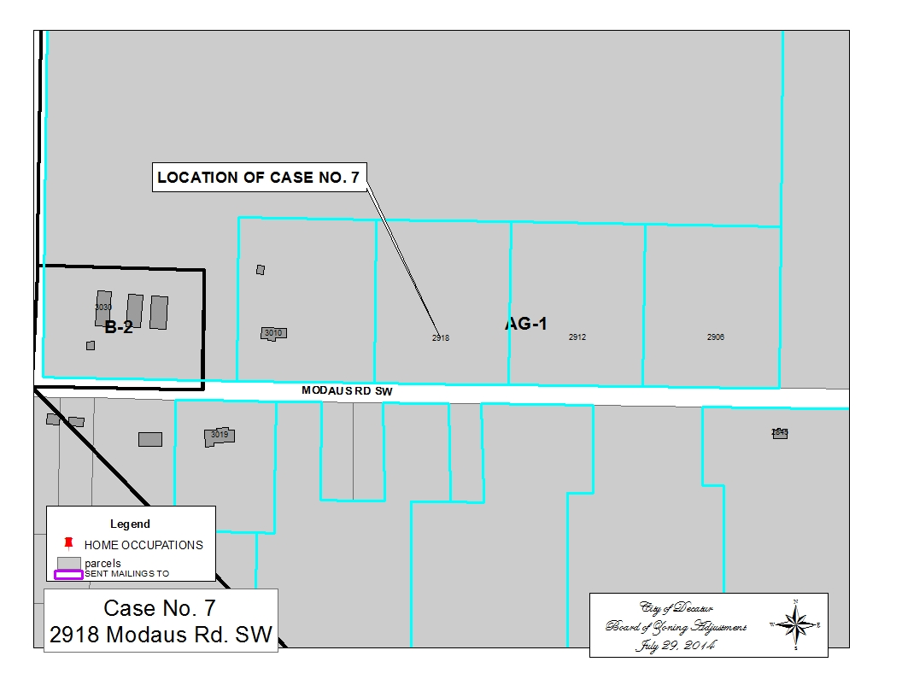

LOCATION MAP 2918 MODAUS RD SW

