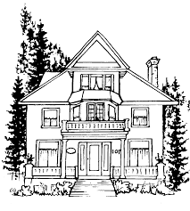

PURCHASING A HOME IN HISTORIC
DECATUR, ALABAMA

THE OLD DECATUR AND ALBANY DISTRICTS

This information is provided courtesy of the
Historic Preservation Commission of Decatur

WHAT MAKES DECATUR HISTORIC?

The city of Decatur, Alabama has an incredibly rich and varied history. In fact, it is a history lover’s dream.
This documented history began as much as 10,000 years ago with The Quad, a Paleo/Archaic Native American site, a relative rarity for the southeastern United States. Cherokee, Chickasaw and Creek people all resided in this area and in the 1830s many passed through Decatur on the Trail of Tears, the forced removal to the West of the eastern Native American people. The city has a National Parks Service trailhead to commemorate these events as well as official historical markers and trails.
The tiny village of Rhodes Ferry was renamed “Decatur” in 1820 pursuant to an executive order of then President James Monroe to memorialize the life of naval hero Stephen Decatur. The town’s lots were laid out in 1824 and later incorporated in 1826.
Beginning about 1815 riverboats began to ply the Tennessee River, beginning the relationship between land and water that created the city’s nickname of “The River City”. The 1830s brought to the city the now oldest bank building in Alabama, the Old State Bank. This bank in the early 1830s financed the first railroad west of the Allegheny Mountains, the eastern terminus of which was in Decatur.
Strategically important for its river and railroad assets and location, the city was virtually totally destroyed during the Civil War including the events of the Battle of Decatur where 30,000 men were on the field.
With the city needing complete reconstruction after the war, Southerners rebuilt homes, stores and churches in the area now known as “Old Decatur” while Northern industrialists and Southern partners built an adjacent new town of “New Decatur”, later renamed Albany, beginning in the mid to late 1880s. The two towns competed architecturally to build the best homes, stores and churches possible, thereby creating one of the largest intact Victorian districts in the Southeast. Today, the city’s two distinctive downtowns and two main historic residential districts (comprising over 100 blocks of stunning yet affordable historic homes of many different architectural styles) host the Historic Decatur Christmas tour which has been named a top 20 tourism event in the Southeast.
After the Civil War railroads and other industries were expanded and created in the 1880s giving the city a continuous 130 plus year industrial history.
There are five major history museums within a block of each other in the Old Decatur (Bank Street) Downtown and a major natural history museum slated to open in the Albany downtown in 2017. The city’s wildlife refuge was established in 1938 and contains a wonderful museum and wildlife observation center as well. Additional museums are currently in the planning stages. If you love history, then Decatur should be your home!
WHAT IS AN HISTORIC DISTRICT IN DECATUR?
The citizens of Decatur are fortunate to have nearly 1,000 residential, commercial and public buildings which have been designated as historical or architectural treasures through inclusion on the National Register of Historic Places and/or the register (inventory) of the Alabama Historical Commission. These buildings possess unique character that is found nowhere else in the city, therefore, it is crucial to the preservation of the rich history and culture of the city that these properties be conserved for both the present and future generations. Recognized historic districts and buildings include Old Decatur, Albany (with later additions to the south of Delano Park), Old Town East, Old Town West, the Bank Street Commercial District, the Second Avenue Commercial District and the Old State Bank, Union Depot, Dancy-Polk house and Burleson House all near the historic railroad bridge.

WHAT IS THE HISTORIC PRESERVATION COMMISSION OF DECATUR?
The HPC of Decatur is a group of seven appointed officials who have significant ties with historic preservation in the city and who have specialized expertise in this area who have the responsibility of protecting specific assets both for the city and also the investments of individual homeowners in two of the city’s residential districts, Old Decatur and Albany. The architects, materials experts, restoration experts and historians of the HPC are always pleased to furnish free advice on both the history of and the restoration of the homes in these districts.
Most, but not all, homes in Old Decatur and Albany are covered by the city’s historic preservation ordinance (last modified in 1990) which establishes and governs the HPC. To determine whether or not a particular home is in the “overlay district” governed by the HPC, contact the Coordinator of the HPC for further information.
The historic preservation ordinance and HPC policies govern most exterior alterations, additions and replacements to existing buildings and construction of new buildings and certain landscape features such as fences, driveways, pools and structures not attached to houses.
TextTextText

WHEN DOES THE HPC MEET AND WHAT GOVERNS ITS WORK?
The HPC meets on the second Thursday of each month at 6:30 pm for its work session immediately followed by 7:00 pm consideration of Certificates of Appropriateness and other business. The HPC meets in the theater room of the historic 1905 Union Depot, 701 Railroad Street (Railroad at Vine Streets).
The work of the HPC is governed by the city’s ordinance on Historic Preservation, the HPC’s policies and procedures and the design review guidelines based on the United States Secretary of the Interior’s Standards for Historic Rehabilitation developed by the National Park Service, all of which can be found on the website found by a search engine: decaturalabamausa.com click on “Departments” click on “Historic Preservation” click on “documents download”) and the HPC’s interpretations of these design review guidelines which are specific to our historic properties in Decatur. The design review guidelines set forth best practices for treatment of individual properties and preserving the special character of the districts. Note that the overall standards of the Secretary of the Interior govern historic preservation commissions throughout the entire nation and by law govern all decisions of the HPC.
A copy of the HPC’s interpretations of those design review guidelines as well as the other documents above can also be accessed at the Decatur Building Department (Fourth Floor of City Hall) and also at the office of the HPC Coordinator at the Old State Bank at 925 Bank Street.
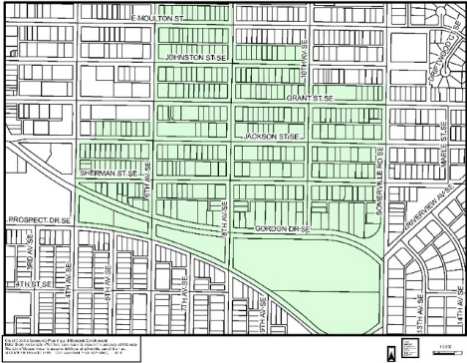
ALBANY OVERLAY DISTRICT
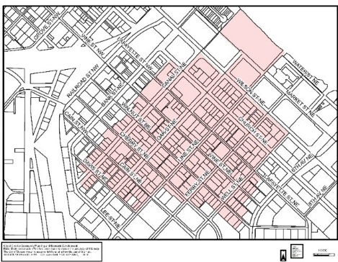
OLD DECATUR OVERLAY DISTRICT
WHAT IS A CERTIFICATE OF APPROPRIATENESS AND WHO MUST APPLY FOR ONE?
For all projects that result in an exterior change to properties in the “overlay district” other than painting a surface which has already been previously painted, an application for a COA must be filed with the Building Department and approved by the HPC as a condition of issuance of a building permit. COA applications must be completed in full per the instructions attached to the COA in order to be set for hearing. There is no fee for filing a COA or for the HPC hearing. COA applications can be obtained at the Building Department, the office of the HPC Coordinator or online. Purely and totally interior modifications, regardless of scope of the project, do NOT require HPC approval. Exterior paint colors do NOT require HPC approval.

WHY PURCHASE PROPERTY IN AN HISTORIC DISTRICT IN DECATUR?
While state and national registry designations do not generally confer legal protections or restrictions to affected properties in and of themselves, they often enhance values. That has certainly historically been true in Decatur. The protections afforded to all homes in the overlay district in Decatur by the city ordinance on historic preservation have not only preserved our rich history but have also provided that the special character of its homes and ambiance is insured. Passage of the current city ordinance was encouraged by a large majority of residents from both Old Decatur and Albany to maximize both values and preservation in these districts. Additionally, some restoration projects may be eligible for state and/or federal tax incentives. Contact the Coordinator of the HPC for more information. The HPC forms are easy to complete, “hearings” are informal and informative and the HPC approves an extremely high percentage of applications (in 2015, for example, 97% of applications were approved with some being modified by proponents to ensure better outcomes).

CONTACTS FOR MORE INFORMATION
David Breland is the current Director of Historic Resources and Events for the City of Decatur as well as Coordinator (non-voting) of the Historic Preservation Commission. Judge Breland, a life-long resident of Decatur, will be delighted to meet with you to discuss the city’s history, the purchase of historic homes in Decatur as well as keys to positively navigate the Historic Preservation Commission process.
256-341-4818 (office) or 256-565-3788 (cell)
Office located at the Old State Bank, 925 Bank Street, Decatur AL
P.O. Box 582, Decatur. AL 35602
Email: dbreland@decatur-al.gov
Also visit the website for the City of Decatur at
decaturalabamausa.com Click on Departments then Historic Preservation then documents download or other click on as desired.

