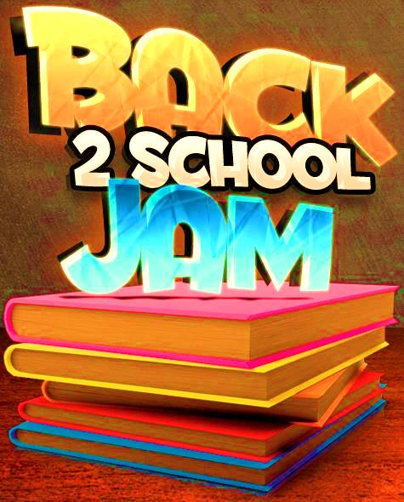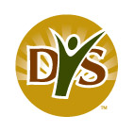

**Decatur Youth Services & housing authority**

**Presents our Annual**

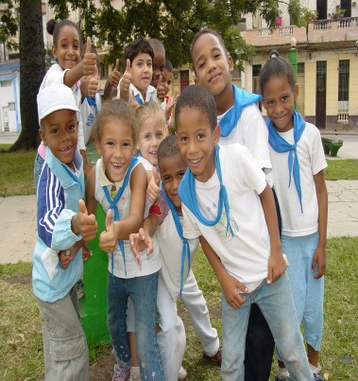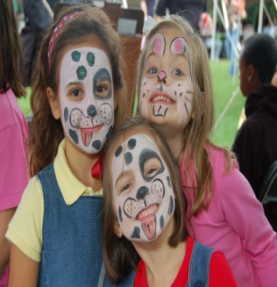

**CONTACT NUMBER**

**256-341-4690**

* **HAIRCUTS AND MORE!!**
* **Sponsored by domino’s pizza**
* **GAMES, WATER SLIDES & BOUNCE HOUSES**
* **FOOD & DRINKS**
* **Vendors welcome**
* **FREE BACKPACKS**
* **Talent show**

**WHERE: INGALLS HARBOR**

**802 WILSON STREET, HWY 20 NW, DECATUR, AL 35601**

* **SCHOOL SUPPLIES**

**WHEN: FRIDAY, AUGUST 4, 2017**

**4PM TO 9PM**