BOARD OF ZONING ADJUSTMENT

AGENDA

January 28, 2014

TABLE OF CONTENTS
MINUTES November 26, 2013 3
AGENDA JANUARY 28, 2014 7
CASE NO 1 1302 6TH AVE SW 9
QUESTIONNAIRE 10
LOCATION MAP1302 6TH AVE SW 11
CASE NO 2 2202 NAPLES DR SW 12
QUESTIONNAIRE 13
LOCATION MAP 2202 NAPLES DR SW 14
CASE NO 3 2307 ROCKINGHAM LANE SW 15
QUESTIONNAIRE 16
LOCATION MAP 2307 ROCKINGHAM LN SW 17
CASE NO 4 2024 CLAYTON AVE SW 18
QUESTIONNAIRE 19
LOCATION MAP 2024 CLAYTON AVE SW 20
case no 5 2026 jefferson ave sw 21
QUESTIONNAIRE 22
LOCATION MAP 2026 JEFFERSON AVE SW 23
CASE NO 6 2114 STRATFORD PL SE 24
SURVEY 25
LOCATION MAP 2114 STRATFORD PL SE 26
CASE NO 7 720 APPALOOSA LN SW 27
PICTURE OF PROPOSED HOUSE 28
SURVEY 29
LOCATION MAP 720 APPALOOSA LN SW 30

MINUTES November 26, 2013

MEMBERS PRESENT: Chairman Kent Lawrence, Messrs. George Barran and Larry Waye, Mr. Greg Dobbs and Ms. Frances Tate

SUPERNUMERARIES: Ms. Sally Jo Green and Mr. Mike Harris

OTHERS PRESENT: Mr. C. Wallace Terry, Building Director and
……Custodian of Records
Mr. Herman Marks, Jr., City Attorney
Mr. Chip Alexander, Asst. City Attorney
Mr. Bob Sims, Inspector
Mrs. Karen Smith, Planner
Ms. Judy Bosworth, Recorder

Chairman Kent Lawrence called the meeting to order at 4:00 p.m. in the Council Chambers at City Hall. Mr. Bob Sims called the roll.

Mr. Greg Dobbs moved to approve the minutes of the October minutes as printed, Mr. Larry Waye seconded the motion. On a roll-call vote, the motion carried.

The Board considered the following applications and appeals.

CASE NO 1

Application and appeal of LaJuan D. Clark for a determination as a use permitted on appeal as allowed in Section 25-10 and as defined in Article VI, as amended and adopted, of the Zoning Ordinance to have an administrative office for a trucking company at 2506 13th St SE, property located in a PRD-6 Planned Residential Zoning District.

Mr. LaJuan D. Clark presented this case to the Board. Mr. Clark stated he would like a office in his house in order to have a physical address for his trucking business that is based out of Texas. Mr. Clark further stated no business would be conducted out of his home or even in the Decatur area.

Mr. Sims stated the Building Department would recommend approval.

Mrs. Smith stated the Planning Department would recommend approval.

Mr. George Barran moved to approve this home occupation request as submitted. Mr. Larry Waye seconded the motion. On a roll-call vote, the motion carried.

CASE NO 2

Application and appeal of Ella Martin for a determination as a use permitted on appeal as allowed in Section 25-10 and as defined in Article VI, as amended and adopted, of the Zoning Ordinance to have an administrative office for an on-line wholesale business as well as a wedding consultant, and jewelry design business at 3503 Pinehurst DR SW, property located in a R-2 Single-Family Zoning District.

Ms. Ella Martin presented this case to the Board. Ms. Martin stated she would like an administrative office for her wedding consultant business and on-line wholesale business. Ms. Martin also stated there would be no customers coming to her home.

Mr. Sims stated the Building Department would recommend approval.

Mrs. Smith asked Ms. Martin how would clients see her products, Ms. Martin stated the products could be viewed on-line. Mrs. Smith stated the Planning Department would recommend approval.

Mr. George Barran moved to approve this home occupation request as submitted. Mr. Larry Waye seconded the motion. On a roll-call vote, the motion carried.

CASE NO 3

Application and appeal of Seth Adgate for a determination as a use permitted on appeal as allowed in Section 25-10 and as defined in Article VI, as amended and adopted, of the Zoning Ordinance to have an administrative office for a graphics and video design business at 1018 Sherman ST SE, property located in a R-3-H Single-Family Historic Zoning District.

Mr. Seth Adgate presented this case to the Board. Mr. Adgate stated he would like an administrative office for an on-line graphic design business. Mr. Adgate also stated there would be no employees and no traffic coming to his home.

Mr. Sims stated the Building Department would recommend approval.

Mrs. Smith stated the Planning Department would concur with the Building Department.

Mr. Larry Waye moved to approve this home occupation request as submitted. Ms. Frances Tate seconded the motion. On a roll-call vote, the motion carried.

CASE NO 4

Application and appeal of Terry and Liliya Taylor for a determination as a use permitted on appeal as allowed in Section 25-10 and as defined in Article VI, as amended and adopted, of the Zoning Ordinance to have an administrative office for a food service business at 4505 Arrowhead DR SE, property located in a R-1 Single-Family Zoning District.

This case was moved to the end of the meeting since no one came forward to present the case when called.

CASE NO 5

Application and appeal of Terry and Liliya Taylor for a use permitted on appeal to Section 25-113 to have a temporary business selling ethnic cuisine from a food trailer in the parking lot at 214 6th Ave SE, property located in a B-2 General Business Zoning District.

This case was moved to the end of the meeting since no one came forward to present the case when called.

CASE NO 6

Application and appeal of Gemstone Foods for a variance from Section 25-16(2) of the Zoning Ordinance to be able to deviate from the required on-site employee parking at 641 Holly St NE, property located in a M-1 Light Industrial Zoning District.

Mr. Tom Caddell, attorney for Gemstone Foods stated his clients were seeking a variance from the on-site parking requirements and that he had been working with his clients for some months now to find a solution to the parking issue. Mr. Caddell further stated the lot across Holly Street seemed to be the solution to the on-site parking issue . Mr. Caddell also explained the business had been in existence for many years but had recently been bought.

Mr. Mike Wellborn new owner of Gemstone Foods explained the business had grown since he acquired it at the beginning of this year and they were currently working on a solution to the parking demands. Mr. Wellborn further stated there was a hardship related to the on-site parking.

Mr. Blake McAnally, Engineer stated he was working on a parking lot layout with 115 parking spaces which would also be ADA accessible. Mr. McAnally further explained this would be more than adequate parking for the number of employees . Mr. McAnally also stated to the Board no trucks owned by the company would be parked in the parking lot as this site is for employee parking only.

Mr. Mike Welborn stated Gemstone Foods would like to be allowed to park the trucks that do not contain chicken products on Mr. Hill’s property which is located on the north side of Holly St NE.

Chairman, Kent Lawrence questioned if the trucks were interchangeable or could they mark the trucks in some manner to be able to tell the difference between the ones that actually carried product and the ones that carried ice or CO2.

Mr. Wallace Terry stated that as long as the trucks were washed clean, he had no problem with parking the trucks on Mr. Hill’s property.

Mr. Blake McAnally stated they are ready to start construction just as soon as the plans are approved by the Planning Department . Mr. Blake McAnally also sated they could be completed with the project by May 1, 2014 as long as the weather cooperated.

Mr. Tom Caddell stated he was still looking for a copy of the recorded deed for the parking lot property.

Mr. Sims stated the Building Department would recommend approval after item two on the condition list was changed to state the following: No trailer, refrigerated or otherwise, equipment, product storage containers related to the business at 641 Holly St NE shall be parked at a location in the City of Decatur that has not been approved by City of Decatur Building Department or by the Board of Zoning Adjustment. Only trailers that contain dry products, ice or that have been washed cleaned are allowed to be located on the property that is to serve in part for parking. Trailers cannot be parked in required parking spaces.

Mr. Mike Wellborn stated Gemstone Foods could comply with amending item number two.

Mrs. Smith stated she would be glad to work with attorney Caddell in locating the deed and to make the parking lot situation better.

Mr. Larry Waye moved to approve this variance request with the condition item number two on the afore mentioned list be changed as stated in the meeting and the project be completed by May 1, 2014. Mr. Greg Dobbs seconded the motion. On a roll-call vote, the motion carried.

Case numbers 4 and 5 were called again. When no one came forward to present the cases, both cases were dismissed by the Board.

The meeting adjourned at 4:40

Chairman, Kent Lawrence

AGENDA JANUARY 28, 2014

CASE NO 1

Application and appeal of Dionisio M. Guerra for a determination as a use permitted on appeal as allowed in Section 25-10 and as defined in Article VI, as amended and adopted, of the Zoning Ordinance to have an administrative office for a general contractor business at 1302 6th Ave SW, property located in a R-2 Single-Family Zoning District.

CASE NO 2

Application and appeal of Celia Hamrick for a determination as a use permitted on appeal as allowed in Section 25-10 and as defined in Article VI, as amended and adopted, of the Zoning Ordinance to have an administrative office for a business to sew and monogram children’s clothing at 2202 Naples Dr SW, property located in a R-2 Single-Family Zoning District.

CASE NO 3

Application and appeal of James G. Pruett for a determination as a use permitted on appeal as allowed in Section 25-10 and as defined in Article VI, as amended and adopted, of the Zoning Ordinance to have an administrative office for a Pas lawn cleaning (lawn mowing) business at 2307 Rockingham Lane SW, property located in a R-2 Single-Family Zoning District.

CASE NO 4

Application and appeal of Bonnie J. Goodman for a determination as a use permitted on appeal as allowed in Section 25-10 and as defined in Article VI, as amended and adopted, of the Zoning Ordinance to have an administrative office to sew custom quilts and other items at 2024 Clayton Ave SW, property located in a R-2 Single-Family Zoning District.

CASE NO 5

Application and appeal of Stephen Motsinger for a determination as a use permitted on appeal as allowed in Section 25-10 and as defined in Article VI, as amended and adopted, of the Zoning Ordinance to have an administrative office to book entertainment at local venues at 2026 Jefferson Ave, property located in a R-2 Single-Family Zoning District.

CASE NO 6

Application and appeal of Tolly G. Shelton for an 11 foot rear-yard setback variance to Section 25-10 of the Zoning Ordinance in order to construct steps at 2114 Stratford Pl SE, property located in a R-1 Single-Family Zoning District.

CASE NO 7

Application and appeal of Charles Moye for a 2 foot front-yard setback variance from Section 25-10.3(2)(d) of the Zoning Ordinance and a 2.5 foot rear yard setback variance from Section 25-10.3(2)(e) of the Zoning Ordinance in order to construct a house at 720 Appaloosa Ln SW, property located in a R-5 Single-Family Zoning District.

CASE NO 1 1302 6TH AVE SW

QUESTIONNAIRE
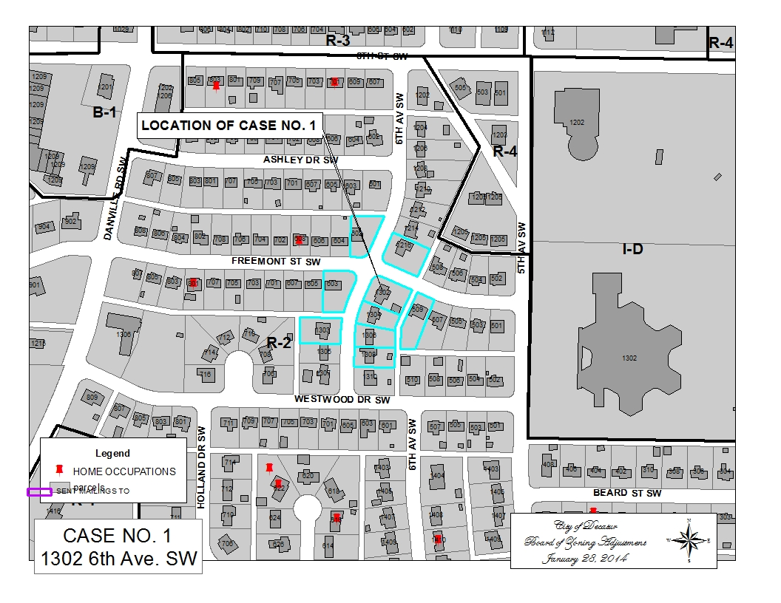

LOCATION MAP1302 6TH AVE SW

CASE NO 2 2202 NAPLES DR SW

QUESTIONNAIRE
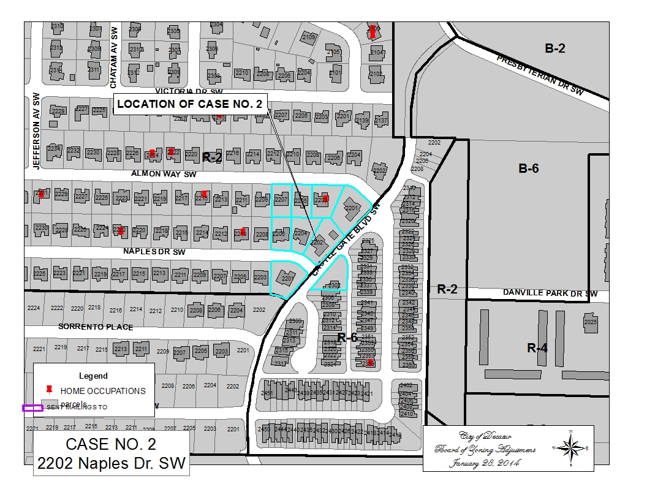

LOCATION MAP 2202 NAPLES DR SW

CASE NO 3 2307 ROCKINGHAM LANE SW

QUESTIONNAIRE

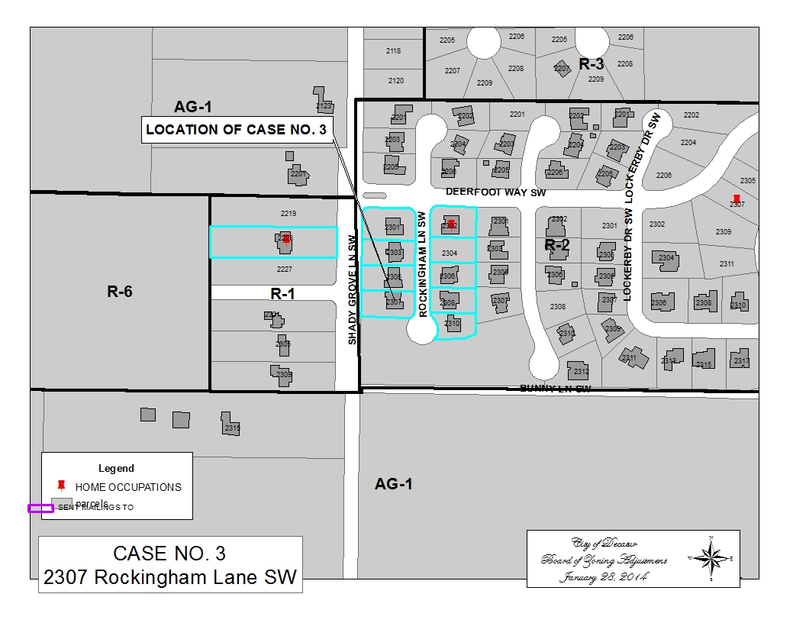

LOCATION MAP 2307 ROCKINGHAM LN SW

CASE NO 4 2024 CLAYTON AVE SW

QUESTIONNAIRE
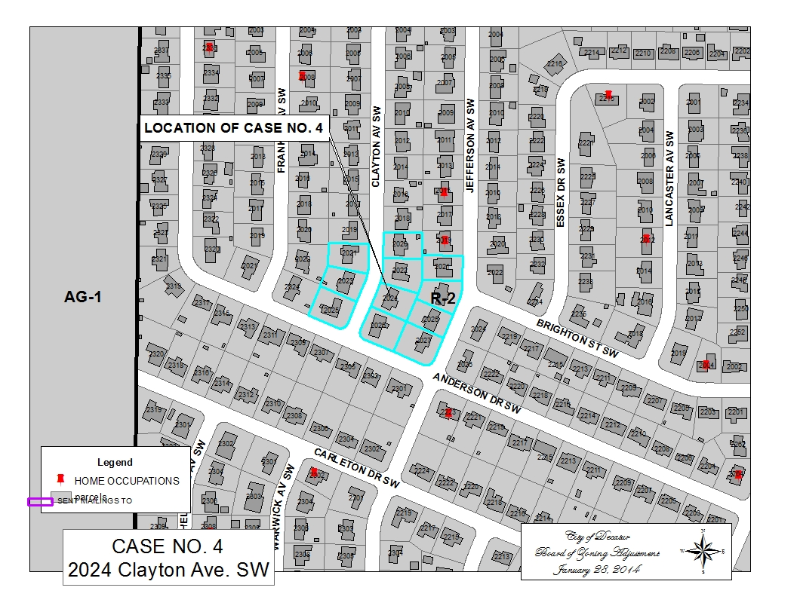

LOCATION MAP 2024 CLAYTON AVE SW

case no 5 2026 jefferson ave sw

QUESTIONNAIRE
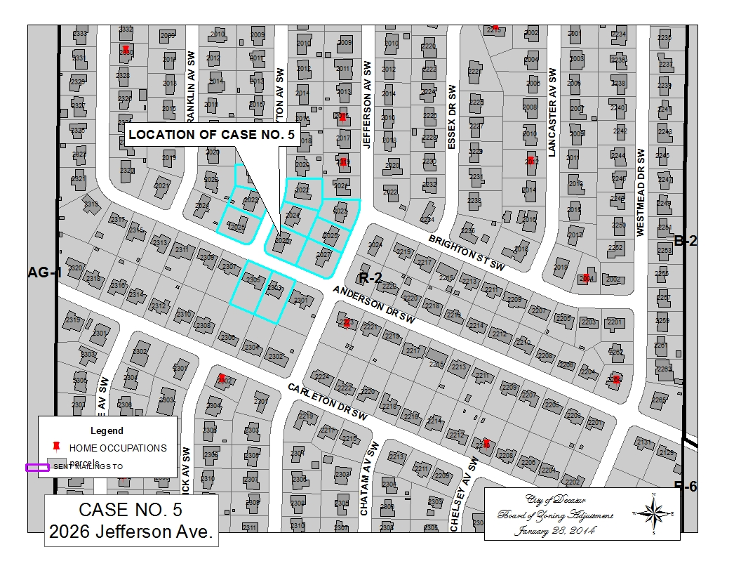

LOCATION MAP 2026 JEFFERSON AVE SW

CASE NO 6 2114 STRATFORD PL SE

SURVEY
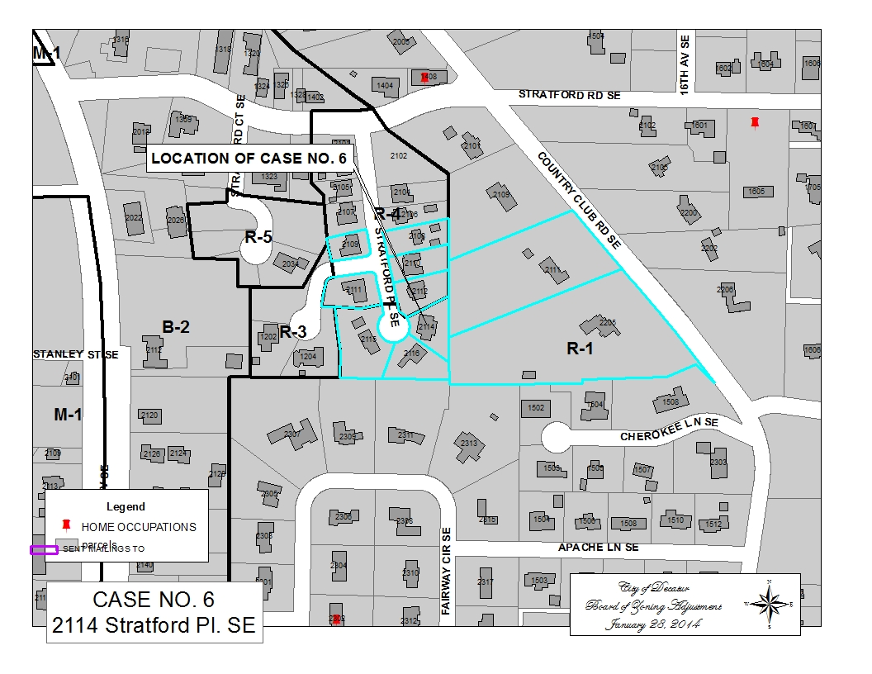

LOCATION MAP 2114 STRATFORD PL SE

CASE NO 7 720 APPALOOSA LN SW

PICTURE OF PROPOSED HOUSE

SURVEY
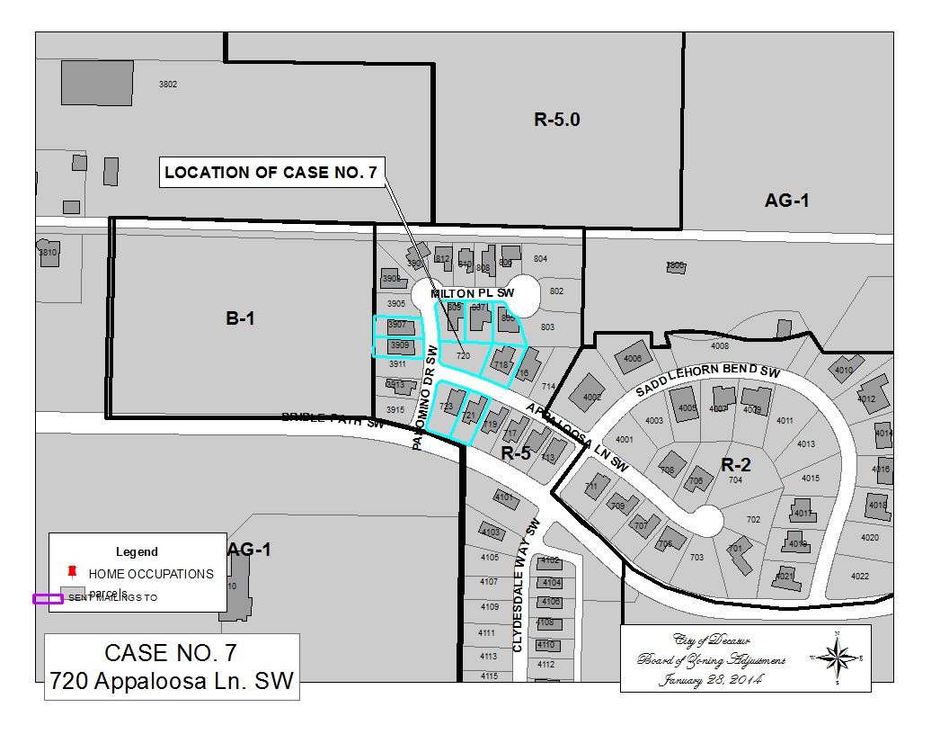

LOCATION MAP 720 APPALOOSA LN SW

